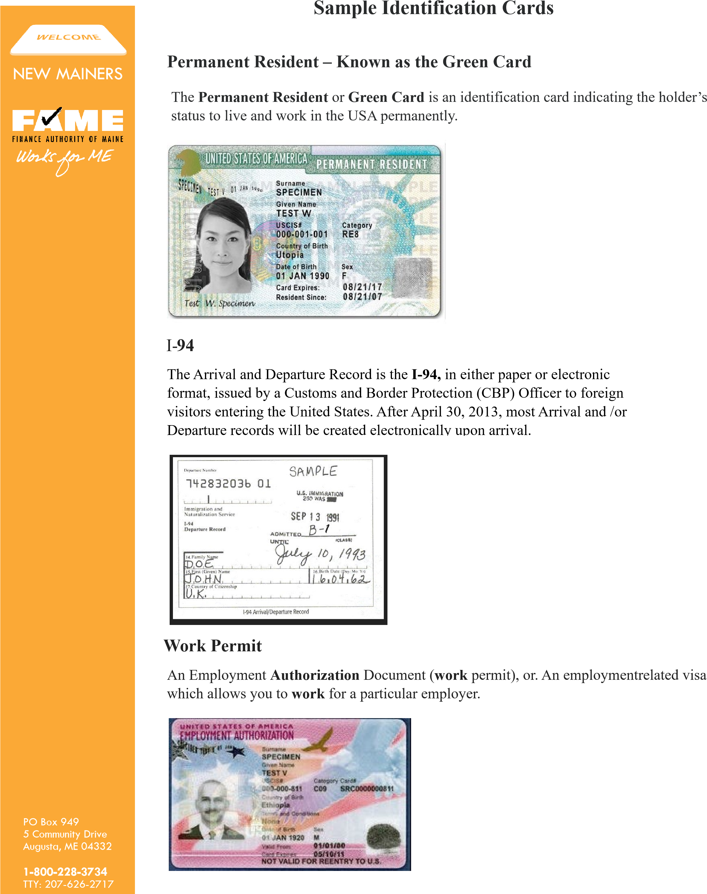
Social Security for Work Authorization Only
If your card states “Valid for Work Only with DHS Authorization," it means you are authorized to work temporarily, but you must provide additional documentation, such as an Employment Authorization Document (EAD), to prove your eligibility to work. Having an SSN for work authorization only does not make an individual eligible for federal student aid.
