Grande Du Maine
Chester Worthington Scholarship
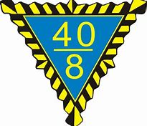
Instructions
- This is a Scholarship for nursing students only.
- Read carefully and answer all questions,
- Type or print clearly all information.
- Do not omit any information. If an item does not apply write N/A.
- The applicant must have completed one semester in a nursing curriculum.
6. The applicant must be in an accredited Associate or Bachelor degree nursing program.
7. The Scholarship will be awarded at the Forty& Eight Grande Promenade in May. The recipient will be asked to attend the award presentation.
8. Submit application by: April 1, 2022
Submit application to: Jesse Pierce
P.O. Box 165
Buckfield, Maine 04220
207-336-3601
10. Applicants must be Maine residents.
11. Please provide:
a. A copy of the applicant’s transcript of grades
b. At least one typed page on your past volunteerism, community service, and why you should be awarded this scholarship
*Applications must be completed in full or they will not be accepted.

